# **Grape Diseases Detection Model**

Used **YOLOv11m** for the detection and classification of tomato leaf diseases.

## **Dataset Details**

* **Total Images:** 5779
* **Split:**
  1. **Train Set:** 4648 images
  2. **Validation Set:** 698 images
  3. **Test Set:** 433 images
* **Number of Classes:** 7
* **Classes:**
  1. Black_measles
  2. Black_rot
  3. Botrytis
  4. Downy_mildew
  5. Esca
  6. Healthy
  7. Leaf_blight

## **Training Setup**

* **Base Model:** yolo11m.pt
* **Training Parameters:**
  + Epochs: 100
  + Image size: 640 × 640
  + Batch size: 8
  + Optimizer: AdamW, lr0 = 0.001
* **Training Logs Folder:** grape_yolo11

## **Evaluation Metrics**

### **Overall Performance (Validation Set, 698 images, 537 objects)**

| **Metric** | **Score** |
| --- | --- |
| **mAP@50** | 94.1% |
| **mAP@50-95** | 80.3% |
| **Precision** | 94.6% |
| **Recall** | 91.7% |

### **Class-wise Results**

| **Class** | **Images** | **Instances** | **Precision (P)** | **Recall (R)** | **mAP@50** | **mAP@50-95** |
| --- | --- | --- | --- | --- | --- | --- |
| All classes | 433 | 537 | 0.937 | 0.925 | 0.942 | 0.800 |
| Black measles | 40 | 40 | 0.990 | 1.000 | 0.995 | 0.888 |
| Black rot | 87 | 87 | 0.995 | 0.977 | 0.980 | 0.853 |
| Botrytis | 26 | 35 | 0.777 | 0.798 | 0.844 | 0.621 |
| Downy mildew | 38 | 38 | 0.990 | 1.000 | 0.995 | 0.877 |
| Esca | 46 | 46 | 0.929 | 0.978 | 0.952 | 0.841 |
| Healthy | 148 | 208 | 0.898 | 0.721 | 0.830 | 0.652 |
| Leaf blight | 83 | 83 | 0.977 | 1.000 | 0.995 | 0.868 |

## **Graphical Results**

### **Training & Validation Curves**

* **mAP@50 and mAP@50-95 vs Epochs  
  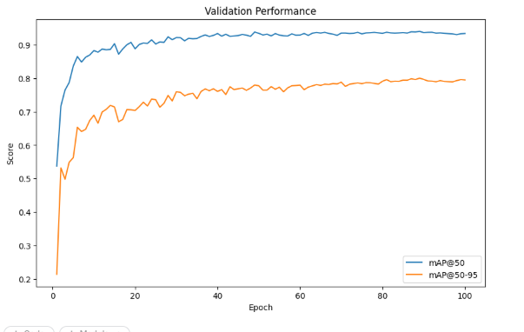**

### **F1, Precision, Precision-Recall and Recall Curves:**

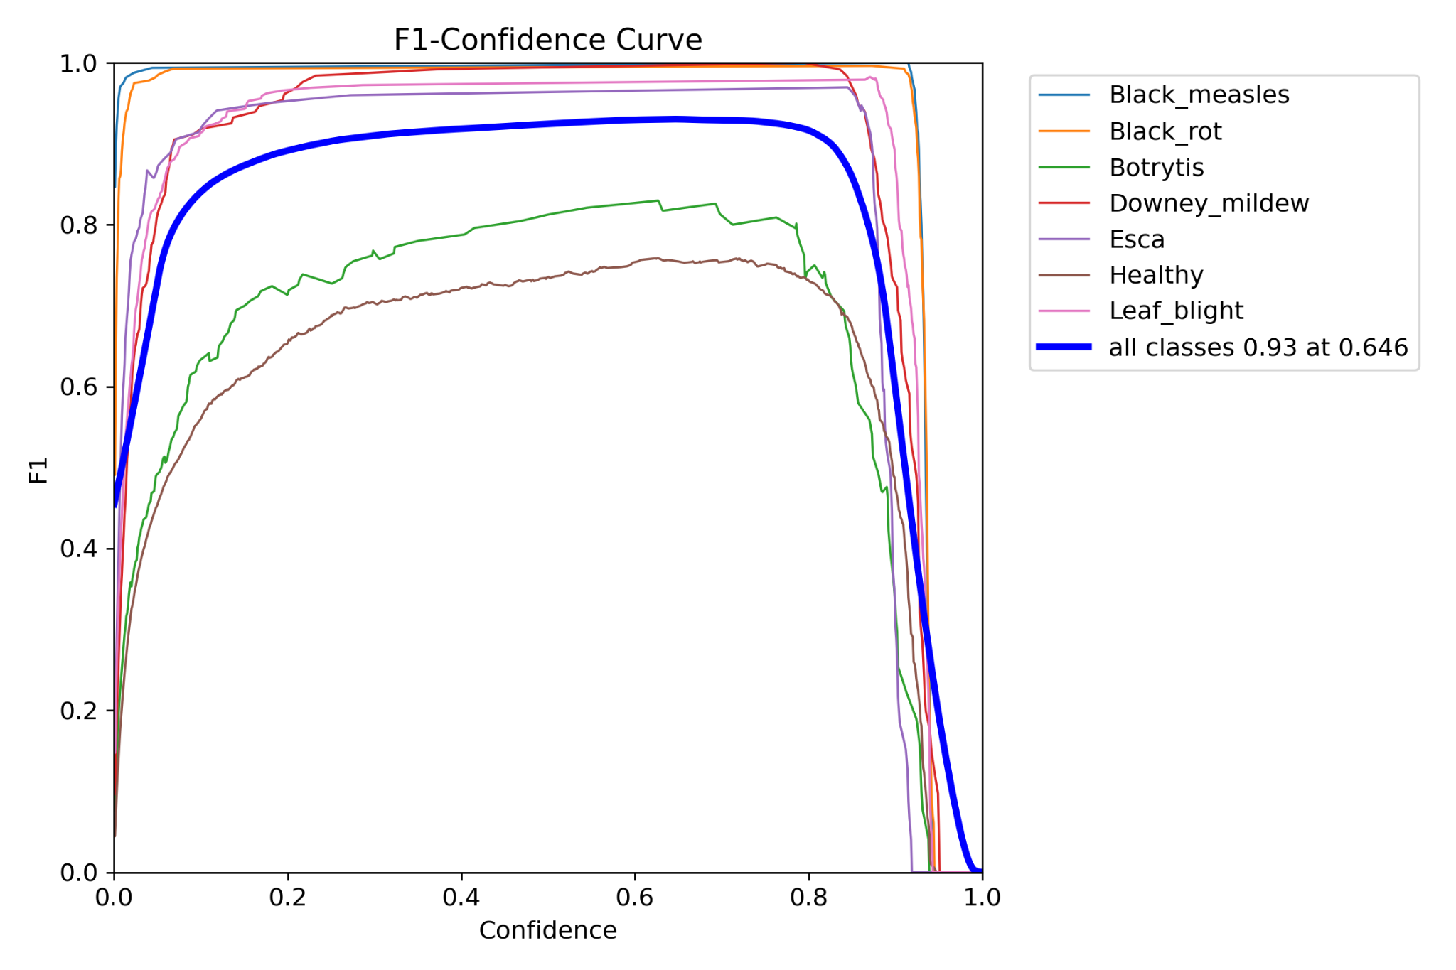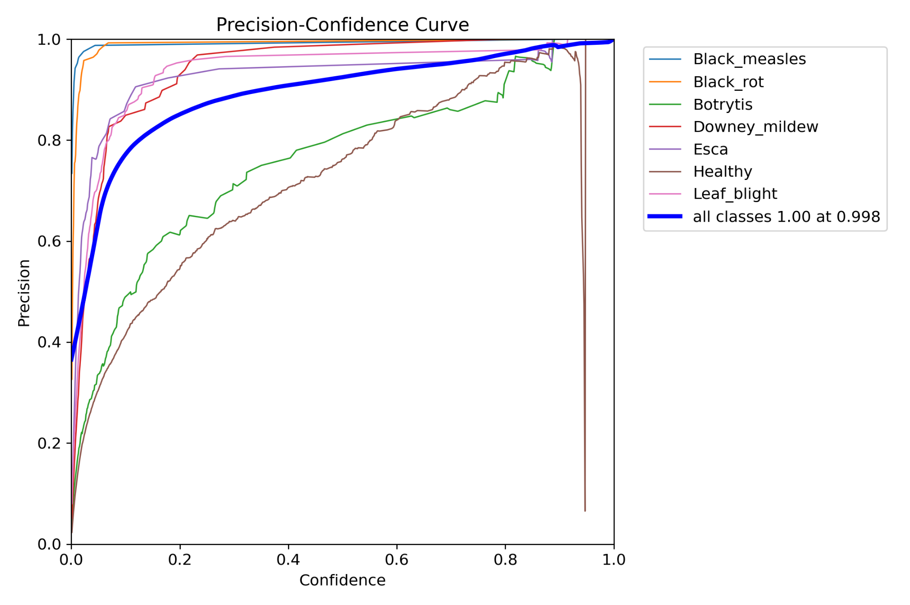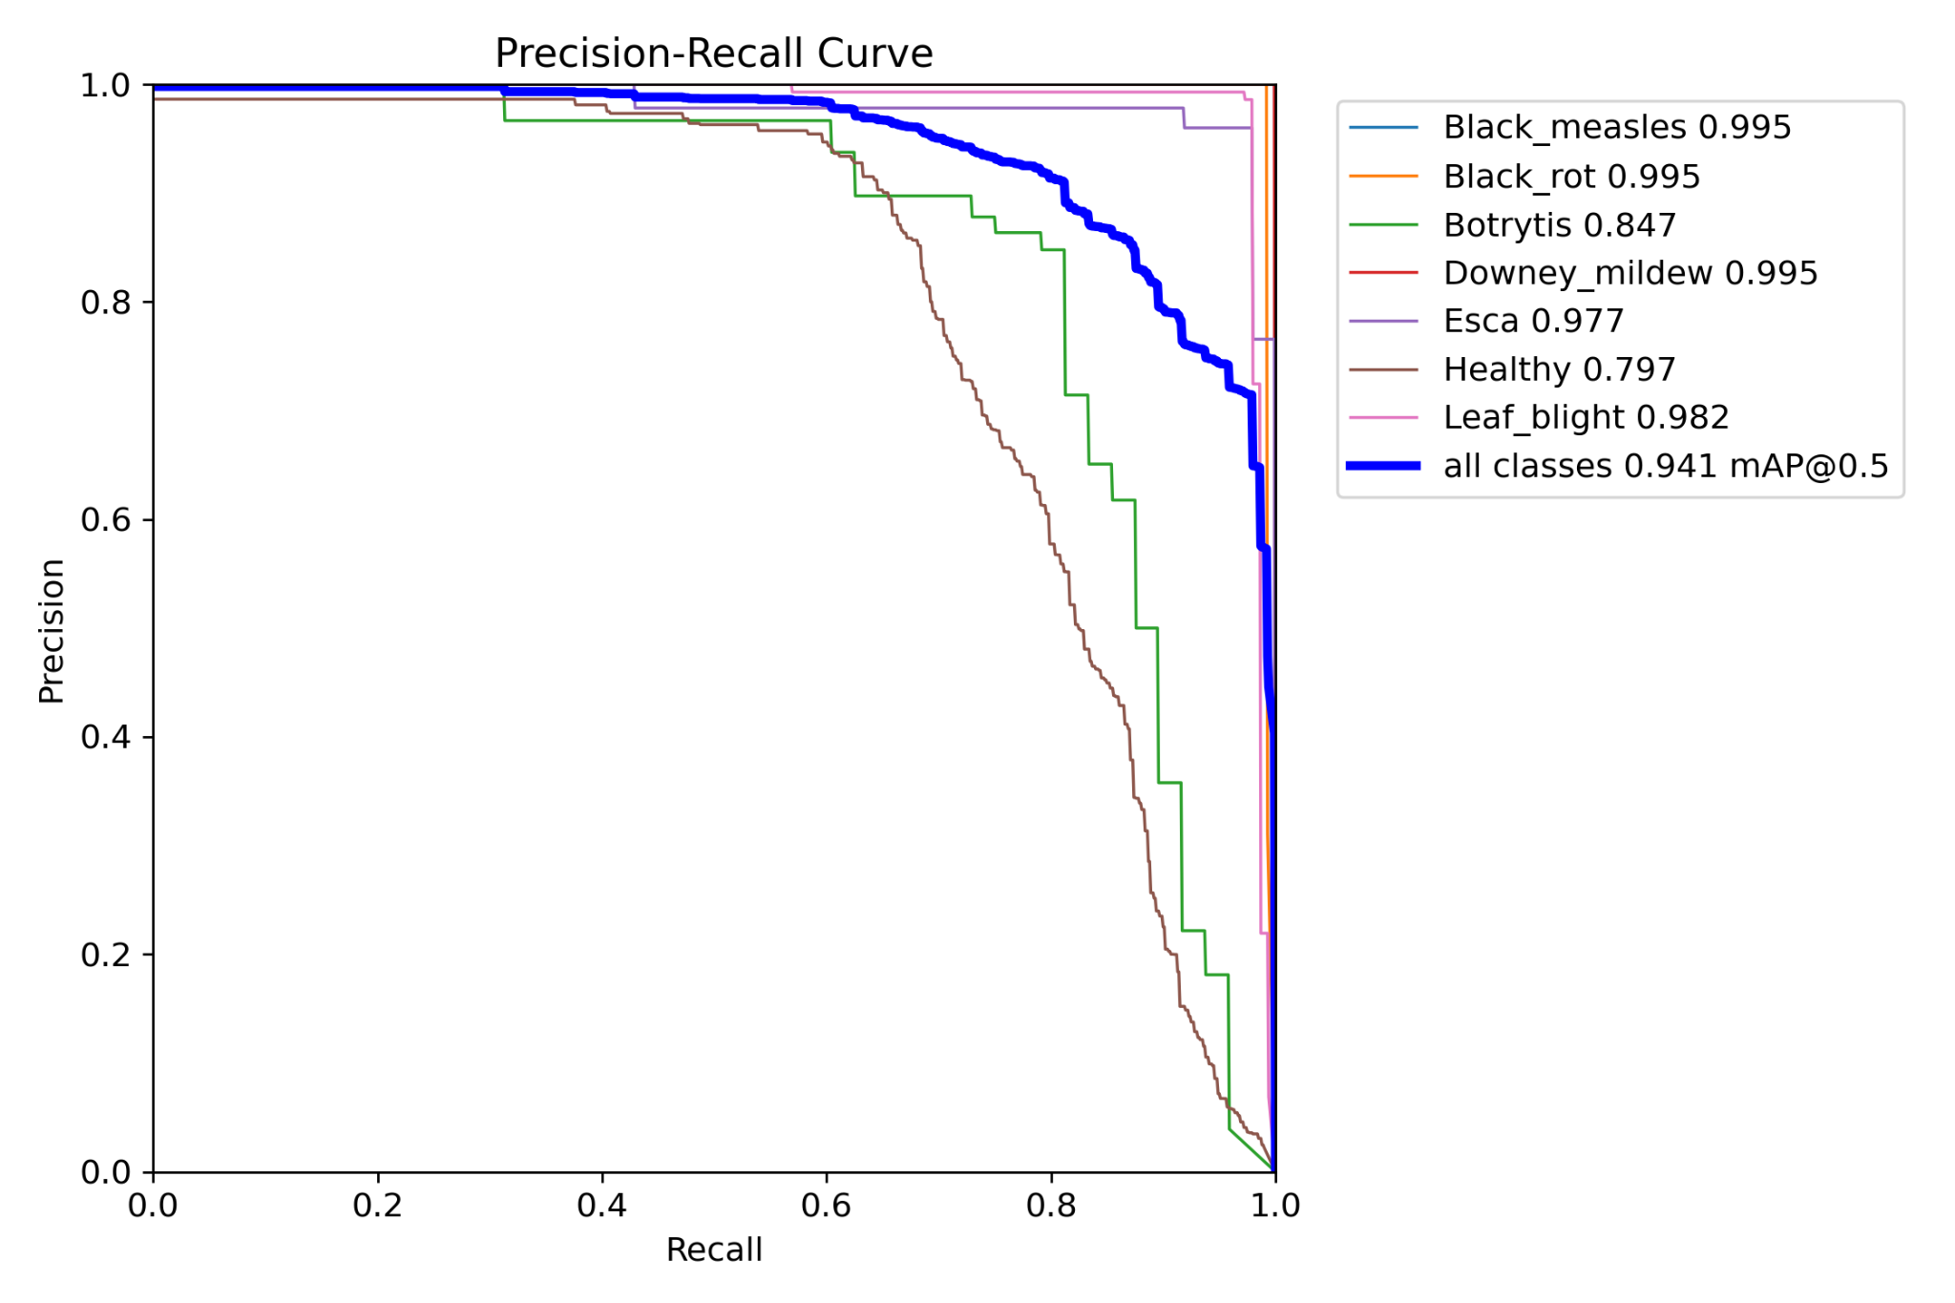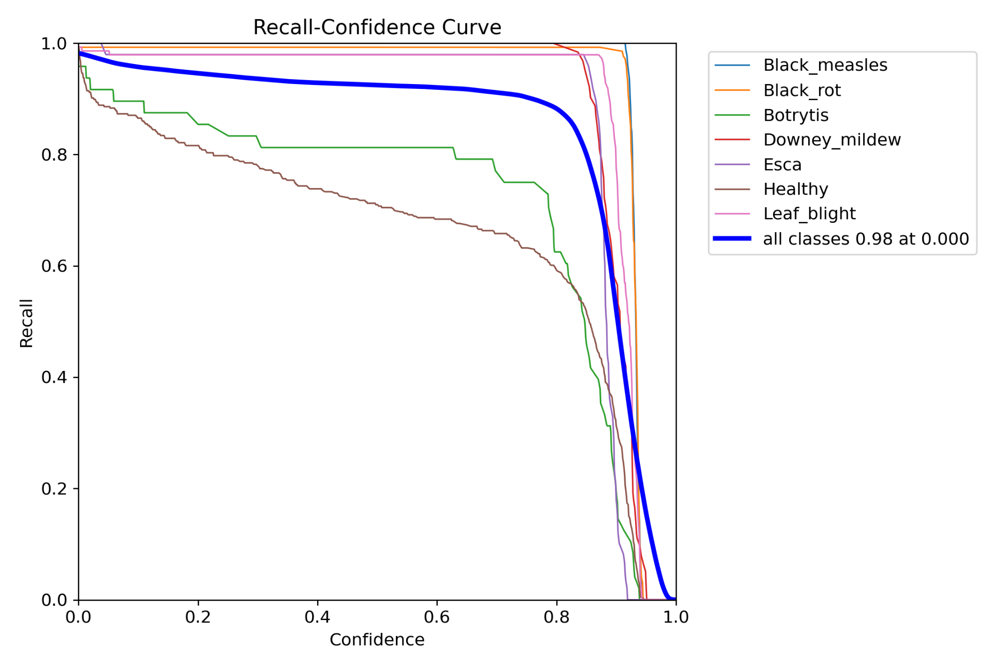

### **Confusion Matrix & Results:**